**Q.1. Write a map reduce program to use Sequence file as input and save the output in key value output format.**

**Driver:**

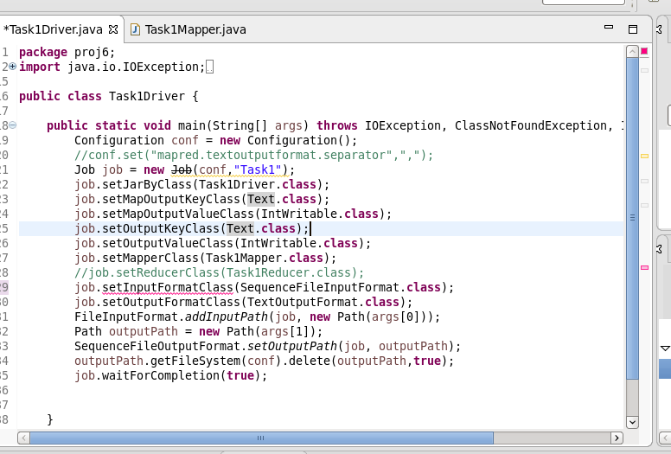

**Mapper:**

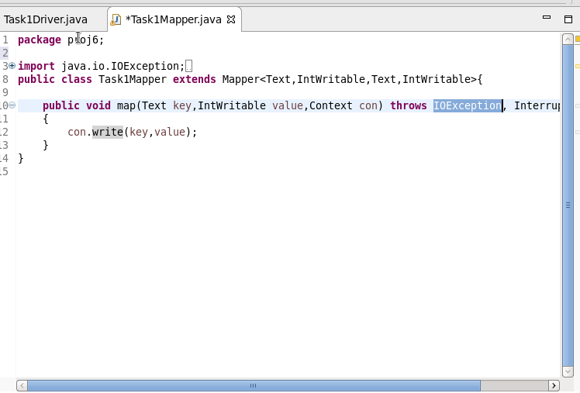

**Output:**

